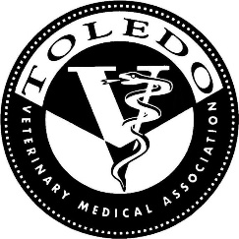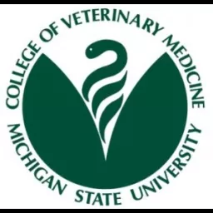

Please join us for a dinner meeting
October 9th 2018
With
Dr. Bryden J. Stanley
BVMS, MACVSc, MVETSc, Diplomate ACVS, Section Chief of Surgery
College of Veterinary Medicine, Michigan State University
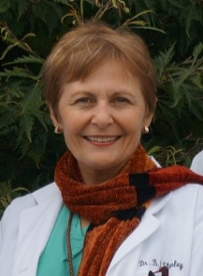
Speaking on
Laryngeal Paralysis and Caesarian Section
At
The Beirut Restaurant
4082 Monroe St. Toledo
Registration: 6:30 p.m.
Dinner and Presentation: 7:00 p.m.
Please RSVP no later than Friday, October 5th
To: Alan G. Moore at
419-474-5403 or agmvet@sbcglobal.net
Attendance is limited to Veterinarians and Technicians
2 CE hours pending approval from OVMLB

